Acetylene Safety Seminar 2010 Malaysia – Programme
Venue: Renaissance Hotel, Kuala Lumpur
Date: 14 October 2010
Topics | Time | Speakers
Opening by chairman of MIGMA | 9.00 – 9.10
i) Opening Speech by DOSH Director General  ii) Introduction by AIGA | 9.10 – 9.20
- General Safety

- Acetylene Incidents, including Incident in acetylene bundle station | 9.20 – 10.00 | Vincent Moreau (Linde)
1.2 Safety topic by Department of Safety and Health | 10.00 – 10.20 | Ke Geok Chuan  DOSH (Malaysia)
Tea Break | 10.20 -10.40
1.3 Preventing accidents through better gas welding  knowledge | 10.40 – 11.20 | Charles Gobi (MOX Linde)
1.4 Safe Handling and transportation of Acetylene cylinders | 11.20 – 12.00 | Jim Lucas (AP)
1.5 Morning session Panel Q & A | 12.00 – 12.15
Lunch | 12.15 – 1.30
- Cylinder and on-site installations
safety

- Emergency response for acetylene cylinder fire/incidents | 1.30 – 2.10 | Vincent Moreau  (Linde)
- Safety features of acetylene cylinders and bundles | 2.10 – 2.50 | Ernest Khoo (AP)
Tea Break | 2.50 – 3.15
2.3 On site customer pipeline installations requirements and safety ( including risk assessment) | 3.15– 3.55 | Yong Niam Pyng (MOX-Linde)
2.4 Afternoon session Panel Q & A | 3.55 – 4.15
Closing | 4.15 -4.25

Jointly organised by:

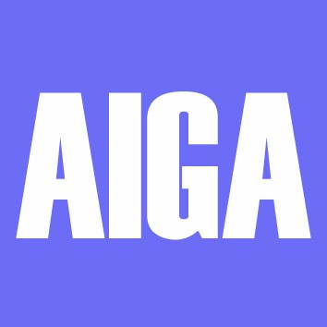
FMM-MIGMA
FMM Malaysian Industrial Asia Industrial Gases
Gases Manufacturers Group Association

